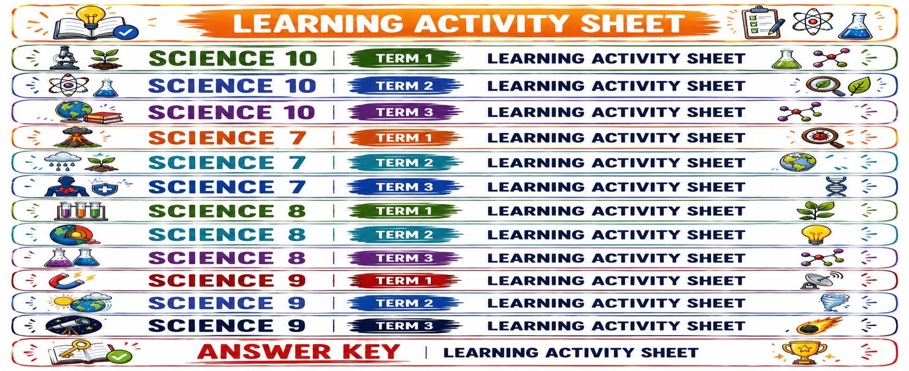

Forces in Action: Push, Pull, and Balanced Forces


Identify that forces act between objects and can be measured.
Identify and describe everyday situations that demonstrate balanced forces.


- Recognize force as a push or pull and identify the unit used to measure force.
- Classify different examples of forces acting between objects and explain that forces can be measured.
- Recognize situations where two or more forces act on an object and identify examples of balanced forces in everyday life.
- Describe how balanced forces affect the motion of an object using everyday situations.


Read each situation carefully. Identify the force or forces involved and determine what the situation tells you about the object's motion.
Situation 1 – Opening a Door
A learner pushes a classroom door to open it.
What type of force is applied?

Is the force a push or a pull?

Situation 2 – Pulling a Bag
A learner pulls a school bag across the floor using its strap.
What type of force is applied?

Is the force a push or a pull?

Situation 3 – A Falling Ball
A ball is released from a certain height and begins moving downward, increasing its speed as it falls.
What force causes the ball to move downward?

Are the forces acting on the ball balanced or unbalanced?

Explain your answer.

Situation 4 – A Book on a Table
A book rests motionless on a table.
Gravity pulls the book downward, while the table exerts an upward force.
Are the forces balanced or unbalanced?

Why?

Quick Check
Answer the following:
- A force is a __________________ or __________________.
- The SI unit of force is the __________________.
- Forces occur through interactions between __________________.
Guide Questions
- What pattern do you notice in the energy values?
- How much energy is transferred from the grass level to the grasshopper level?
- What happens to the amount of available energy as the trophic level increases?
- Why do you think an organism cannot transfer all the energy it obtains to the organism that eats it?
- Based on the data, what do you predict the available energy would be at the next trophic level


Activity 2 – Force Analysis Challenge
Use what you know about forces to analyze each situation.
Part A – Classify the Force
Choose from:
Push – Pull – Gravity – Friction
Situation | Force
1. A learner moves a chair by pushing it forward.
2. Earth attracts a dropped ball downward.
3. A person pulls a drawer open.
4. A bicycle slows down because of contact between its brakes and wheels.
5. A student pushes a box across the floor.
6. A person pulls a bucket upward using a rope.

Part B – Two or More Forces
Study each diagram.
Situation A
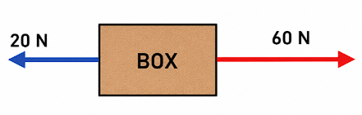
- What are the two forces acting on the box?
- Calculate the net force.
Net force = __________________
- What is the direction of the net force?
- Are the forces balanced or unbalanced?
- What will happen to the motion of the box?

Situation B
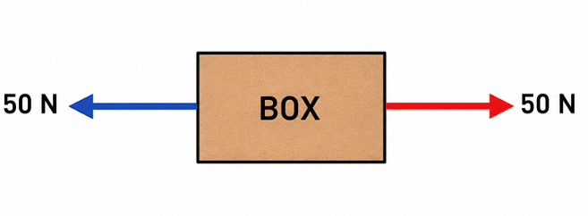
- What are the magnitudes of the two forces?
- Calculate the net force.
Net force = __________________
- Are the forces balanced or unbalanced?
- If the box is initially at rest, what will happen?


Activity 3 – The Delivery Cart Investigation
A school worker pushes a loaded cart along a hallway.
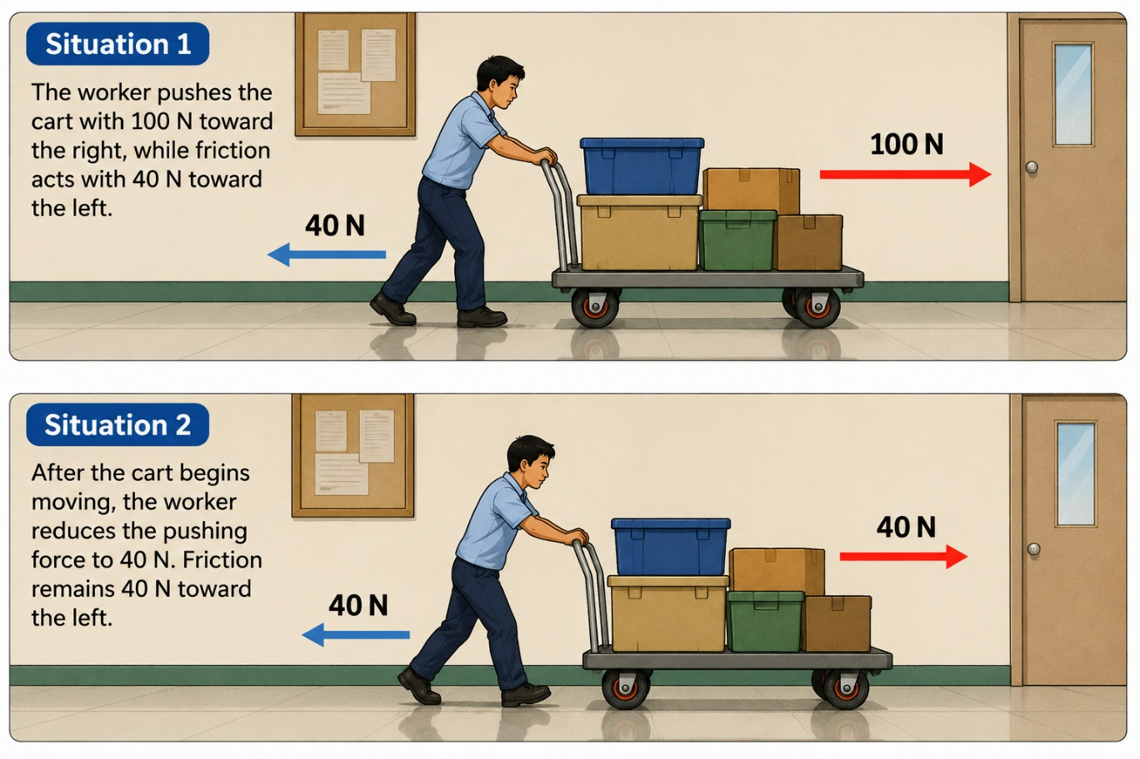
Complete the table.
 | Situation 1 | Situation 2
Forward Force | ______ N | ______ N
Opposing Force | ______ N | ______ N
Net Force | ______ N | ______ N
Balanced / Unbalanced | __________ | __________
Effect on Motion | __________ | __________

Analyze
- Why does the cart accelerate during Situation 1?
- Why does the cart stop accelerating during Situation 2?
- If the cart is already moving when the forces become balanced, will it automatically stop?
Yes / No
Explain.

- What does this investigation demonstrate about the relationship between net force and motion?


Activity 4 – Forces in Everyday Life
Balanced forces can be observed in many situations in everyday life. Analyze each situation and explain how the forces affect the object.
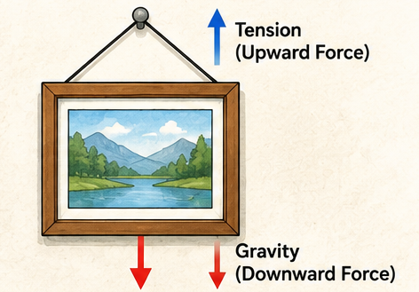
Situation 1 – Hanging Picture
A picture frame hangs motionless on a wall. Gravity pulls it downward while the supporting wire exerts an upward force.
Are the forces balanced or unbalanced?

How do the forces affect the motion of the picture?

Situation 2 – Tug-of-War
Two teams pull a rope in opposite directions. Team A pulls with 500 N, while Team B also pulls with 500 N. The rope remains stationary.
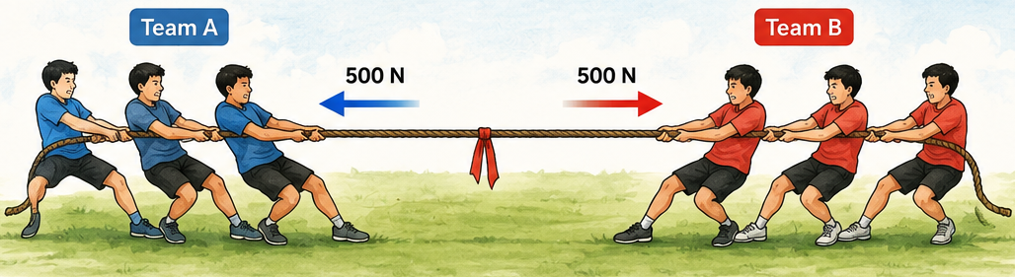
What is the net force?

Are the forces balanced or unbalanced?

Why does the rope remain stationary?

Situation 3 – Moving Bus
A bus travels along a straight road at a constant speed. The forces acting on the bus are balanced.
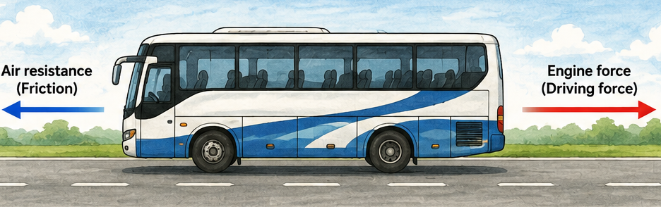
Is the bus moving even though the forces are balanced?

What does this tell you about balanced forces and motion?

Read and answer the following questions.
PISA-Like Multiple-Choice Questions
1. A learner pushes a laboratory table toward the right with a force of 80 N. Another learner pushes the same table toward the left with a force of 50 N.
What does this situation show about the forces acting on the table?
A. The forces are balanced because two forces are acting on the table.
B. The forces are balanced because both forces are measured in newtons.
C. The forces are unbalanced because the net force is 30 N toward the right.
D. The forces are unbalanced because the forces act in opposite directions.

2.A box is resting on a horizontal floor. Gravity pulls the box downward, while the floor exerts an upward force on the box. The two forces have equal magnitudes.
What will most likely happen to the box if no other force acts on it?
A. It will accelerate upward.
B. It will accelerate downward.
C. It will remain at rest because the forces are balanced.
D. It will move horizontally because gravity and the upward force cancel.

3.During a tug-of-war, Team A pulls a rope with 450 N to the left, while Team B pulls with 450 N to the right. The rope remains stationary.
Which statement best explains the situation?
A. No forces are acting because the rope is not moving.
B. The forces are balanced because the two forces have equal magnitudes and opposite directions.
C. The forces are unbalanced because two teams are pulling the rope.
D. The force of Team A is greater because it pulls from the left.

4.A cyclist is traveling along a straight road at a constant speed. The forward force produced by the cyclist is equal to the resistive forces acting backward.
What can be concluded about the net force on the cyclist?
A. The net force is zero, so the cyclist's motion does not change.
B. The net force is forward, so the cyclist must accelerate.
C. The net force is backward, so the cyclist must stop immediately.
D. There is no force acting because the cyclist is moving at constant speed.

5.A student drops a ball from a height. As the ball falls, its speed increases.
Which statement best describes the forces acting on the ball?
A. The forces are balanced because the ball is moving downward.
B. The forces are balanced because gravity acts on the ball.
C. The forces are unbalanced because the ball's motion is changing.
D. There is no force acting because the ball is not being pushed or pulled by a person.

PISA-LIKE OPEN-ENDED QUESTION
6. The School Cart
A school worker pushes a loaded cart along a hallway. At first, the cart is at rest. The worker pushes it with a force of 100 N toward the right, while friction acts with a force of 40 N toward the left.
After the cart begins moving, the worker adjusts the force so that the forward force becomes 40 N, while friction remains 40 N in the opposite direction.

Question
Explain what happens to the motion of the cart during the two situations. Identify whether the forces are balanced or unbalanced in each situation, calculate the net force, and explain how the net force affects the cart's motion.

The Energy That Disappears: Tracking Energy Through a Food Pyramid
The Vanishing Energy Mystery
- The amount of available energy decreases by about 90% at each successive trophic level.
- 2,000 energy units
- The amount of available energy decreases as the trophic level increases.
- Organisms use much of the energy they obtain for movement, growth, reproduction, maintaining body functions, and other life processes. Some is also released as heat.
- 2 energy units

Checking for Understanding 1
Calculate the Transfer
Organism | Trophic Level | Available Energy
Grass | 1 | 30,000 units
Grasshopper | 2 | 3,000 units
Frog | 3 | 300 units
Snake | 4 | 30 units
Explain:
The decreasing values show that only about 10% of the energy available at one trophic level is transferred to the next level. Much of the energy is used for life processes and released as heat.

Analyze the Energy Pyramid
Given:
Trophic Level | Organism | Available Energy
1 | Grass | 50,000 units
2 | Grasshopper | 5,000 units
3 | Frog | 500 units
4 | Snake | 50 units
5 | Hawk | 5 units
- Trophic Level 1 – Producer/Grass
- 500 energy units
- 10%
- Available energy decreases by approximately 90% at each higher trophic level.
- The hawk is at a higher trophic level, so only a small portion of the original energy remains available after successive transfers.

Activity 1: Compare Two Ecosystems
Ecosystem A
Organism | Trophic Level | Energy
Grass | 1 | 40,000 units
Grasshopper | 2 | 4,000 units
Frog | 3 | 400 units
Snake | 4 | 40 units
Ecosystem B
Organism | Trophic Level | Energy
Algae | 1 | 60,000 units
Small Fish | 2 | 6,000 units
Large Fish | 3 | 600 units
Heron | 4 | 60 units
Task 2
Ecosystem B – Pond has more available energy at its highest trophic level.
- Ecosystem A: 40 units
- Ecosystem B: 60 units
Task 3
Ecosystem B begins with more energy at the producer level (60,000 units compared with 40,000 units). Because approximately the same proportion of energy is transferred at each trophic level, more energy remains available at its highest trophic level.

Activity 2: The Ecosystem Investigation
Task 1 – Energy Pyramid
Top → Bottom
Bird of Prey – Level 5
Snakes – Level 4
Frogs – Level 3
Insects – Level 2
Crops – Level 1
Task 2
Trophic Level | Organism | Estimated Energy
1 | Crops | 100,000 units
2 | Insects | 10,000 units
3 | Frogs | 1,000 units
4 | Snakes | 100 units
5 | Bird of Prey | 10 units
Task 3 – Expected Answer
Energy enters the ecosystem through the crops, which are producers. When insects eat the crops, about 10% of the available energy is transferred to the insects. The energy is then transferred from insects to frogs, frogs to snakes, and snakes to the bird of prey, with only about 10% transferred at each step.

When Energy Becomes Limited
- First trophic level
- Second trophic level
- Third trophic level
- Energy moves from crops → insects → frogs.
- Organisms at different trophic levels are connected through feeding relationships, so a change in one level can affect the availability of food and energy at other levels.

PISA-Like Multiple-Choice Questions
No. | Answer
1 | B
2 | B
3 | A
4 | A
5 | C

PISA-Like Open-Ended Question
Expected Answer
Energy begins with the trees, which contain 150,000 energy units at the first trophic level. About 10% is transferred to the caterpillars, giving them 15,000 units. The birds receive about 10% of this amount, or 1,500 units, while the snakes receive 150 units and the hawk receives only 15 units.
Most of the energy is not transferred to the next trophic level because organisms use energy for movement, growth, reproduction, obtaining food, maintaining body functions, and other life processes. Some energy is also released as heat. Therefore, less available energy remains at each higher trophic level.
Energy Pathway
Trees → Caterpillars → Birds → Snakes → Hawk
150,000 → 15,000 → 1,500 → 150 → 15 units
Key Concept
Only about 10% of the energy available at one trophic level is transferred to the next trophic level in the simplified model.

